What is Pentecost Sunday?
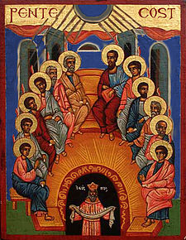An Eastern Orthodox icon of Pentecost
Pentecost is a prominent feast in the calendar of Ancient Israel celebrating the giving of the Law on Sinai, and also later in the Christian liturgical year commemorating the descent of the Holy Spirit upon the remaining eleven disciples of Christ (Judas had hanged himself) after the Resurrection of Jesus. It is also called Whit Sunday, Whitsun, or Whit, especially in the United Kingdom, where the following Monday was traditionally a holiday. Pentecost, meaning "fiftieth day", is celebrated seven weeks (50 days) after Easter Sunday, hence its name.

